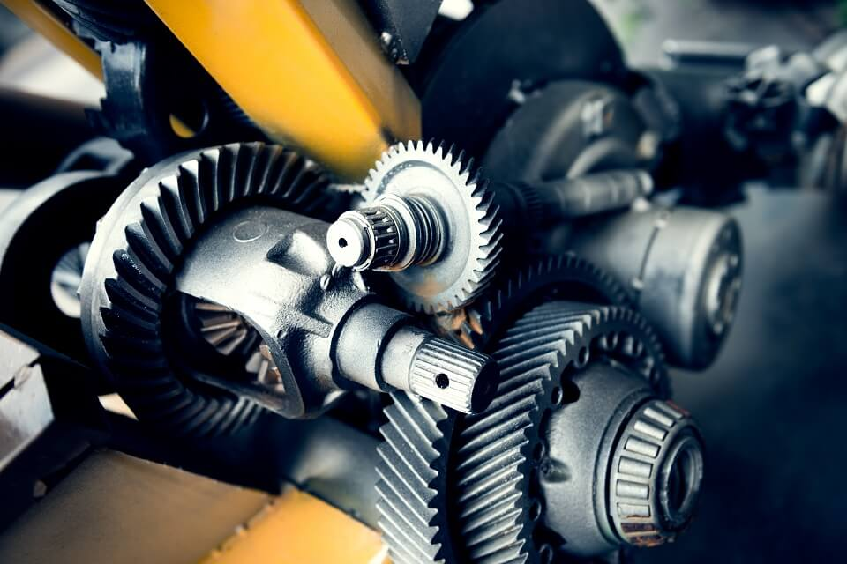

[Pipeline Corrosion Control In The Oil & Gas Industry](https://btsconsultant.com/courses/pipeline-corrosion-control-in-the-oil-gas-industry/)

Training program

**Training Program**

**Introduction:**

Corrosion in pipelines is one of the major challenges faced by oil and gas industries all over the world. This has made corrosion control or management a major factor to consider before setting up any industry that will transport products via pipelines. Some types of corrosion are pitting, microbial, sulfide-stress cracking, hydrogen-stress cracking and hydrogen-induced cracking. These can be caused by poor maintenance of the pipeline system, severe mutilation of the pipeline coatings, substrates due to vandalization and coating failures. However; it can be deduced that the use of cathodic protection technique as a method of controlling corrosion in oil and gas pipelines is effective and efficient when compared to other methods and thus constant monitoring is needed to achieve optimum efficiency.

Crude oil and gas pipelines could be onshore, offshore or in swamp. The transportation operations has remained a high complex and challenging effort against forces of nature. The importance of the use of pipelines as the most efficient means of product conveyance from well head to the gathering-points, from the flow stations to the storage tanks in the terminals and to the loading or export platforms far into the Atlantic cannot be overemphasized. For every new field discovered, the pipelines are further exposed to the test in the harshest environments Irrespective of the field location with all the environment unfriendliness, the plain carbon steel pipes, remains the best means of product transfer from the holes to the well head due to its favorable thermo-mechanical properties.  The crude oil and gas pipelines in the cause of being used for the purpose of transporting products are exposed to various environments especially the offshore installations.

Pipeline are the most reliable, efficient, safe and economic mode of transport for oil, gas, hydrocarbons and water. Rightly considered as lifelines of modern industrial infrastructure, steel pipelines are vulnerable to atmospheric corrosion above ground and electrolytic corrosion in underground / marine environments. Pipeline corrosion can result in colossal losses and create safety hazards for people, assets and environment. Corrosion control is an important requirement for ensuring integrity of pipelines. This course covers various aspects of corrosion of pipelines and methods available for prevention and control of their corrosion. The intention is to arm pipeline operating / maintenance personnel with sufficient knowledge on pipeline corrosion to maintain integrity of pipelines.

**Who Should Attend?**

Corrosion Control Engineers & Personnel, Process Engineers, Metallurgists, Inspection Personnel, Mechanical Engineers, Material Selection Personnel, Plant Contractors, Operations Engineers, Team Leaders & Supervisors, Maintenance Engineers, Maintenance Supervisors,  Senior Plant Supervisors, Mechanical Engineers, Corrosion Control & Monitoring Systems Personnel, Equipment Engineers, Maintenance Engineers and Planners, Team Leaders, Managers & Coordinators, Construction Coordinators, Technologists,  Safety Officers, Maintenance Team Leaders & Engineers, Design Engineers, Service Company Representatives, Oil and Gas Production Facilities Personnel, Chemists, Chemical Engineers, Inspectors and Inspection Engineers & Supervisors, Technicians and Supervisors, Environmental Specialists, New Petroleum Engineers, Asset Management Personnel, Construction Engineers, Refinery Chemists, Chemical Engineers,  Personnel who are / will be responsible for detecting, inspecting, monitoring, controlling corrosion in oil and gas piping, pipelines used in production operations and Personnel responsible for metallurgy, corrosion or the prevention of failures in plant and equipment

**Course Objectives:**

**By the end of this course, delegates will be able to:**

* Learn about various aspects of corrosion of pipelines and methods available for prevention and control of their corrosion
* Gain sufficient knowledge on pipeline corrosion to maintain integrity of pipelines
* Explain the basic functions and purposes of pipelines and facilities and identify the characteristics and hazards of common pipeline products
* Identify maps and drawings used to depict pipelines and facilities
* Explain the roles of control personnel and equipment in the overall operation of a pipeline
* Explain liquid pipeline hydraulics and gas pipeline pneumatics
* Explain the types and purposes of pipeline equipment
* Explain pipeline electrical power systems and corrosion control
* Review operations, maintenance, and emergency procedures and perform documentation required for pipeline operations
* Explain the basic theory of cathodic protection (CP)
* Define galvanic and impressed current CP and explain the advantages and limitations of each system
* Demonstrate how to use instrumentation and meters to monitor CP systems

## Course Outline:

* Pipeline integrity management overview
* Pipeline corrosion and its prevention & control
* Galvanic anode and impressed current cathodic protection systems
* Selection & application of corrosion protection coatings
* Pipeline internal corrosion monitoring
* Measurements and prevention
* Pipeline installation, security managements, maintenance and repairs
* Pipeline external corrosion protection monitoring & health assessment surveys
* Pipeline corrosion case studies
* Coatings
* Cathodic protection
* Electrical interferences
* Plant piping
* Pipeline risk analysis
* Life assessment